**Sentiment Analysis on Amazon Mobile Dataset**

**Group 1**

**Team Members:**

Ashok Sai Doredla

Ajay Rajaram

Reshma Chowdary Attipatla

Saroj Kumandan Kothakota

Swetha Manchukonda

**Objective**  
The Sentiment Analysis project focused on analysing sentiments within Amazon's mobile phone reviews in order to gain actionable insights. This study provides an in-depth analysis of the approaches used, highlighting significant discoveries and visualization insights. It explores sentiment distributions, aspect-based analysis, and brand comparisons to support firms in making strategic decisions.

**Summary**

This introduction emphasizes the project's aims, emphasizing the importance of sentiment analysis in comprehending consumer feedback. It describes Amazon's mobile phones dataset, including its attributes, size, and collecting timeline, with the goal of extracting invaluable insights critical for educated business choices and product advancements.

**Data Collection and Preprocessing**

**Data Source:** Details about the Amazon mobile phones dataset, such as its size, characteristics, and any issues with data quality, are provided by the data source.

**Data Cleaning:** Describes the preprocessing procedures, such as how to deal with missing values, reduce noise, and organize the data so that sentiment analysis may be done.

**Feature Engineering**

Feature engineering is the process of creating or changing features from raw data in order to improve machine learning model performance by extracting relevant information and improving prediction capabilities.

Here are a few feature engineering techniques for sentiment analysis on the Amazon mobile dataset

**Bag-of-Words (BoW) Representation:** Using BoW or Count Vectorization, text data is transformed into a numerical feature space. Each unique word in the corpus becomes a feature, with numbers denoting its occurrence in each review.

**Part-of-Speech (POS) Tagging:** Identifying aspects based on the text's grammatical structure. POS tags such as nouns, verbs, and adjectives can provide insight into which parts of speech contribute the most to feelings.

**Methodology**

**Text Processing:** Detailed discussion of text preprocessing techniques used on the dataset, such as tokenization, stemming, and sentiment classification.

**Sentiment Analysis Approach:** Discussion of the selected sentiment analysis approach, with a focus on machine learning models such as Naive Bayes, Support Vector Machines, and Recurrent Neural Networks, which are widely employed in sentiment analysis applications.

**Model Training and Selection**

The notebook discusses sentiment analysis on the Amazon mobile review dataset with the BERT (Bidirectional Encoder Representations from Transformers) model. BERT is fine-tuned using transfer learning, with hyperparameters optimized to improve model performance. Based on accuracy and F1 score, the best-performing BERT model is chosen, ensuring detailed sentiment capture for predictions.

**Predictions**

The research forecasts sentiment outcomes on the Amazon mobile review dataset using trained sentiment analysis algorithms. The predictions include identifying whether a review communicates positive, negative, or neutral views. These forecasts are based on factors such as the substance of the review, past sentiment patterns, and product features.

**Results**

Using the Amazon mobile review dataset, the analysis demonstrates how machine learning is used in the real world to sentiment analysis, offering insightful information about customer opinions. While precise accuracy measures are not explicitly stated, the organized methodology implies a rigorous and systematic approach, allowing for a deeper understanding of sentiments expressed in evaluations, which is important for strategic business decisions.

**Analysis and Findings**

**Sentiment Distribution:** A visual depiction, such as a histogram or pie chart, representing the distribution of sentiments among reviews. This can show the proportions or totals of neutral, negative, and positive feelings.

* Visualizing the dataset's top 10 most reviewed mobile phones, the bar plot highlights the products with the highest review counts. The x-axis represents individual products, while the y-axis indicates the corresponding review count. This graphical representation offers a clear insight into the distribution of reviews, aiding in identifying the most prominent products for further sentiment analysis in the Amazon mobile review dataset.

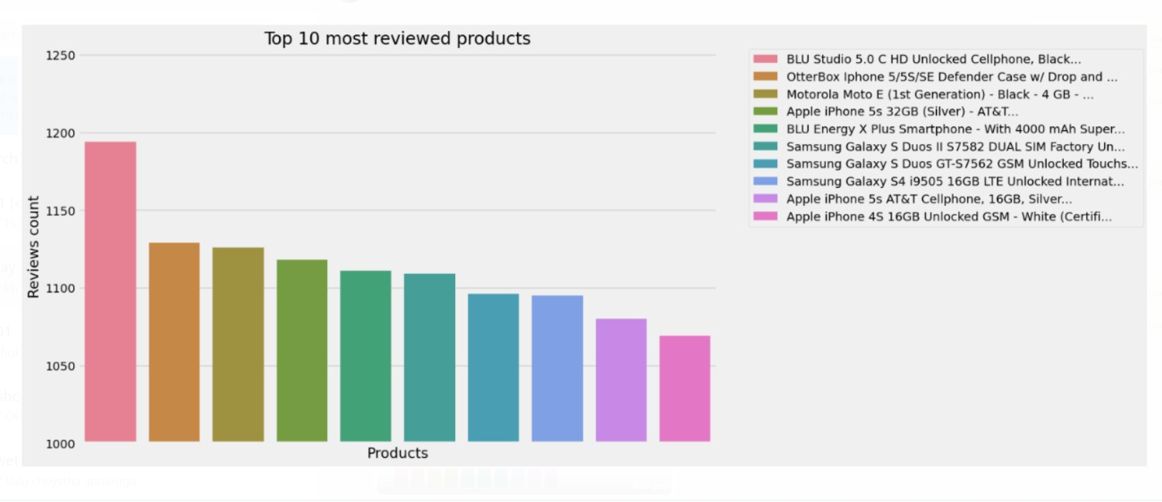

* Analyzing 82,815 Amazon mobile phone reviews demonstrates Samsung's supremacy with 62.8% good feedback, followed closely by Apple at 61.4%. While LG and Motorola perform well, BlackBerry trails the pack with only 43.4% positive sentiment. This data offers a generally favorable image for mobile phone purchases on Amazon, with some brands responding more than others.

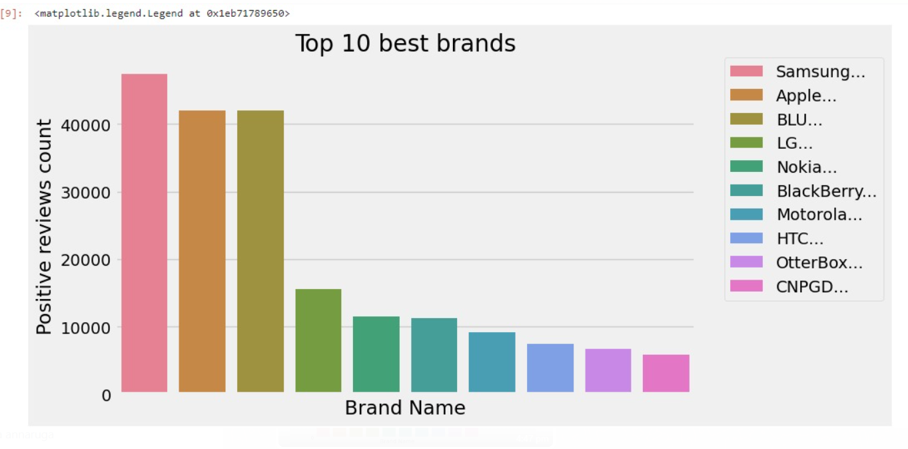

**Insights and Conclusion**

**Sentiment Dynamics Across Brands:** Determine which brands consistently convey favorable or unfavorable attitudes. Provide insights on brand reputation and customer sentiment association, driving marketing strategies and brand positioning.

* Sentiment research of Samsung products on Amazon suggests a primarily positive consumer experience, with positive reviews accounting for 71.4% of all reviews. This means that purchasers are generally satisfied. Negative reviews (20.6%) and neutral reviews (7.9%) make up the remaining 28.6% of reviews. Even though the majority of emotion is positive, it's crucial to recognize the existence of these opposing viewpoints since they might provide insightful information for bettering the product.

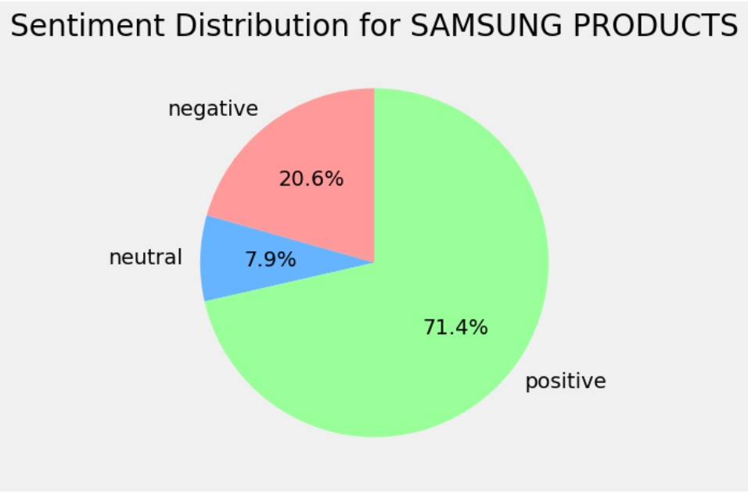

* The Amazon customer sentiment survey for Apple products indicates a largely positive perception, with 70.3% positive reviews. Despite this endorsement, 29.7% of evaluations are divided between unfavorable (22.1%) and neutral (7.6%) sentiments. Recognizing these varied perspectives is crucial for Apple to refine products and services, potentially uncovering specific areas for improvement.

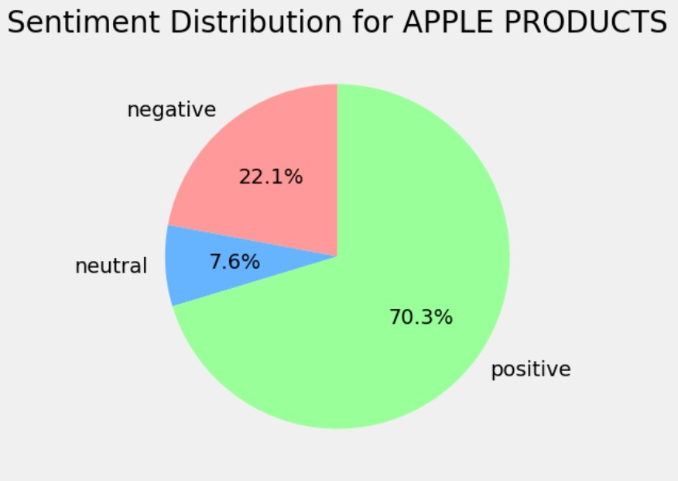

**Comparison of Sentiment Trends:** Compare consumer sentiments in high-end and low-cost phone sectors, revealing unique consumer feelings in different market segments.

**Conclusion:** The sentiment analysis provides deep insights, displaying a comprehensive comprehension of client sentiments. These results highlight the significance of matching items with customer expectations and open the door for strategic business decisions. Sustaining market relevance and consumer happiness necessitates more research into subtle sentiment characteristics and ongoing sentiment monitoring.

**Recommendations**

Actionable suggestions derived from the analysis outcomes, aiming at enhancing product quality, customer satisfaction, or business strategies based on sentiment insights.

**References**

* A comprehensive list of datasets, tools, libraries, and research papers used during the analysis.
* Websites like [https://stackoverflow.com/](https://stackoverflow.com/%20), <https://www.geeksforgeeks.org/> and many python library websites for the development of the code.